BEGUM ROKEYA UNIVERCITY, RANGPUR

DEPARTMENT OF STATISTICS

ASSIGNMENT ON

Course Title : Programming with R and Python
Course Code : STAT-2205

Submitted To:
Dr. Md. Siddikur Rahman
Associate Professor
Department of Statistics

Submitted By: Mst. Arifa Akter
ID : 12210057
Semester : 2nd
Session : 2022-2023
Date of Submission: 21 May 2026

Assignment
Programming with R & Python

Consider airline data includes the following:
- miles: miles travelled through the flight
- passengers: number of passengers on the flight
- delay: take-off delay in minutes
- inflight meal: Is there a meal included in the flight?
- inflight entertainment: are there free entertainment systems for each seat?
- inflight wifi: Is there complimentary wifi on the flight?
- day_of_week: day of the week of the flight
- weekend: Did this flight take place on a weekend?
- coach price: the average price paid for a coach ticket
- firstclass price: the average price paid for first-class seats
- hours: how many hours the flight took
- redeye: Was this flight a redeye (overnight)?
Objective of Analysis: reveal the factors that might influence coach prices within the airline industry.
Solve the questions below using R & Python, including interpretation (select a random sample using your ID):
1. What do coach ticket prices look like? What are the high and low values? What would be considered the average? Does $500 seem like a good price for a coach ticket?
2. What are the high, low, and average prices for 8-hour-long flights? Does a $500 ticket seem more reasonable than before?
3. How are flight delay times distributed? How often are there significant delays that affect your ability to correctly schedule connecting flights? What kinds of delays are typical?
4. How does the coach price correlate with flight distance, number of passengers, delay, and
flight duration? 5. What is the relationship between coach and first-class prices? Do flights with higher coach prices always have higher first-class prices as well?
6. What is the relationship between coach prices and in-flight features: in-flight meal, in-flight entertainment, and in-flight WiFi? Which features are associated with the highest increase in price?
7. How does the number of passengers change in relation to the length of flights?
8. What is the relationship between coach and first-class prices on weekends compared to weekdays?
9. How do coach prices differ for redeyes and non-redeyes on each day of the week?
10. Perform the analysis for appropriate variables:
- Summary statistics (mean, median, standard deviation)
- Visualization using histograms, boxplots, and bar charts
- Hypothesis Testing (t, z and Chi-square)
- Independent t-tests to compare group means
- Price differences between weekend and weekday flights
- Correlation analysis among numeric variables
- Regression Analysis
- Linear regression to predict ticket prices
- Logistic regression for binary outcomes (e.g., redeye flights).
Introduction
The airline industry is highly dynamic, where ticket prices are influenced by multiple operational and service-related factors such as flight distance, travel duration, delays, passenger volume, weekend schedules, and in-flight facilities. Understanding the relationship between these variables and ticket prices is important for both airline companies and passengers.
This analysis focuses on identifying the major determinants of coach ticket prices using statistical analysis and machine learning techniques in Python. The dataset contains information related to airline flights including miles traveled, passengers, delays, in-flight services, ticket prices, flight duration, and travel schedules.
The objective of this study is to explore patterns in airline ticket pricing and determine which variables significantly affect coach ticket prices.
First of all, we need to install some necessary libraries to solve this task.
Python Libraries:
# Basic Libraries
import pandas as pd
import numpy as np
# Visualization Libraries
import matplotlib.pyplot as plt
import seaborn as sns
# Statistical Libraries
from scipy import stats
# Machine Learning Libraries
from sklearn.model_selection import train_test_split
from sklearn.linear_model import LinearRegression, LogisticRegression
from sklearn.metrics import mean_squared_error, r2_score, accuracy_score,
confusion_matrix, classification_report
# Ignore warnings
import warnings
warnings.filterwarnings('ignore')

R libraries:
# Install packages if necessary
install.packages(c("tidyverse", "ggplot2", "dplyr", "corrplot", "car"))

# Load libraries
library(tidyverse)
library(ggplot2)
library(dplyr)
library(corrplot)
library(car)
Programming Implementations:
R code for load dataset:
# Import dataset
airline<-read.csv('C:/Users/HP/Desktop/python/flight_data.csv')
Python code for load dataset :
# Load dataset
airline=pd.read_csv('C:/Users/HP/Desktop/python/flight_data.csv')
# Display first 5 rows
airline.head()
Output:
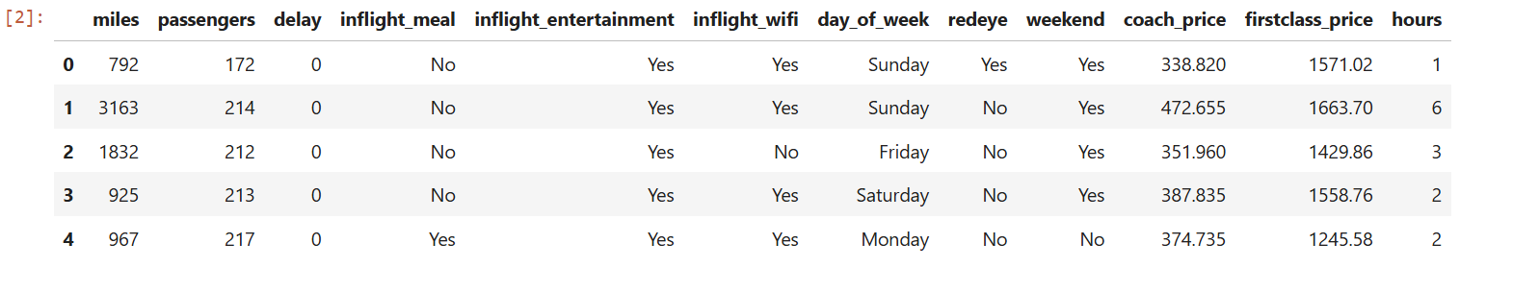
Choose Random Sample:
A random sample of 10,057 observations was selected from the original airline dataset to ensure that the analysis remains computationally efficient while still representing the overall population characteristics. Random sampling helps reduce selection bias and allows statistical findings to be generalized to the broader airline dataset.
Programming Implementations:
R code for random sample:
set.seed(42)
sample_airline <- airline[sample(nrow(airline), 10057), ]
#for same sample
sample_airline<-read.csv('C:/Users/HP/Desktop/python/flight_data.csv')
View(sample_airline)

Python Code For Random Sampling:
# Random sample of 10057 rows
sample_airline = airline.sample(n=10057, random_state=42)

# Now use sample_airline everywhere
sample_airline.head()
Output:
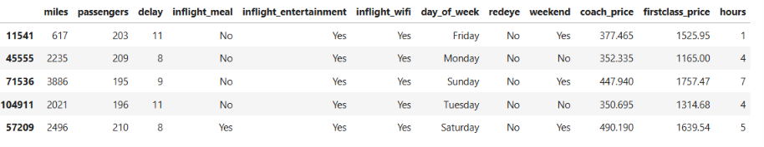
Convert Categorical Variable to Numeric:
Several categorical variables such as in-flight meal availability, entertainment service, WiFi facility, weekend flights, and redeye flights were converted into binary numerical values (0 and 1). This transformation was necessary because statistical models and machine learning algorithms require numerical input variables for computation.
In the converted format:
- 1 represents the presence of a feature or a “Yes” response.
- 0 represents the absence of a feature or a “No” response.
Python code for binary column:
binary_cols = ['inflight_meal', 'inflight_entertainment',
'inflight_wifi', 'redeye', 'weekend']

for col in binary_cols:
sample_airline[col] = sample_airline[col].map({'Yes':1, 'No':0})
sample_airline
Output:
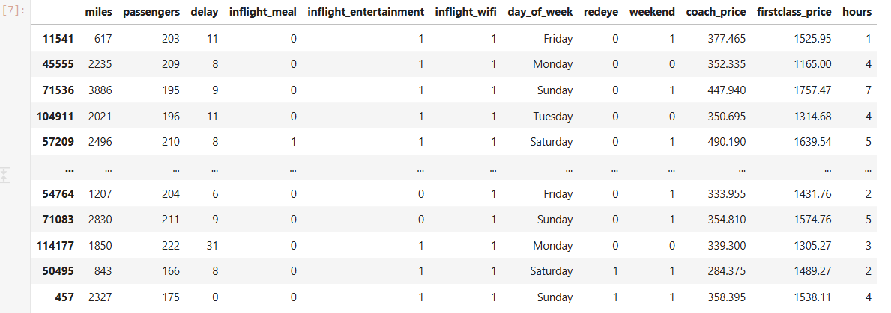
Q1. What do coach ticket prices look like? What are the high and low values? What would be considered the average? Does $500 seem like a good price for a coach ticket?
Programming Implementations:
R code:
# Summary statistics
summary(sample_airline$coach_price)

mean(sample_airline$coach_price)
median(sample_airline$coach_price)
sd(sample_airline$coach_price)
min(sample_airline$coach_price)
max(sample_airline$coach_price)

install.packages("ggplot2")
library(ggplot2)
ggplot(sample_airline, aes(x = coach_price)) +
geom_histogram(fill = "skyblue", color = "white", bins=30) +
geom_vline(aes(xintercept=376.59), color = "red", linetype = "dashed", size = 1) +
labs(title = "Coach Price Distribution", x = "Coach Price ($)", y = "Frequency")
ggplot(sample_airline, aes(y = coach_price)) +
geom_boxplot(fill = "blue") +
labs(title = "Boxplot of Coach Ticket Prices")
Python code:
# Summary statistics for coach price
coach_summary = sample_airline['coach_price'].describe()
print(coach_summary)
Output:
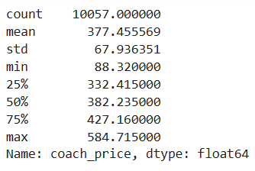
#histogram
plt.figure(figsize=(8,5))
sns.histplot(sample_airline['coach_price'], bins=30, kde=True)
plt.title('Distribution of Coach Ticket Prices')
plt.xlabel('Coach Price')
plt.ylabel('Frequency')
plt.show()
Output:
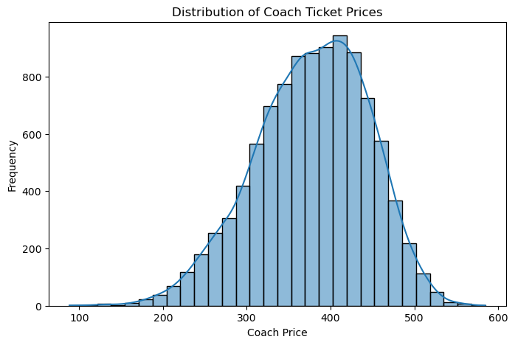
#boxplot
plt.figure(figsize=(7,4))
sns.boxplot(x=sample_airline['coach_price'])
plt.title('Boxplot of Coach Ticket Prices')
Output:
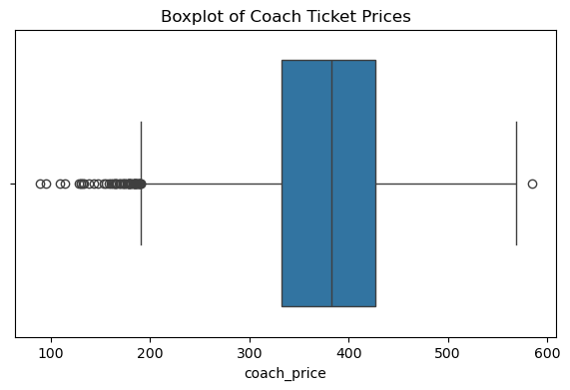
Interpretation:
The distribution of coach ticket prices appears approximately unimodal and moderately symmetric, centered around the $380–$400 range. The histogram indicates that most ticket prices are concentrated between approximately $330 and $430, suggesting relatively consistent pricing within the dataset. The calculated mean ticket price is about $377.60, while the median is approximately $382.43, indicating that the distribution is fairly balanced with only slight negative skewness.
The minimum observed ticket price is around $88.32, whereas the maximum reaches approximately $584.72, demonstrating a substantial overall price range. The boxplot reveals several lower-end outliers, implying that a small number of unusually cheap tickets exist compared to the majority of observations.
Considering the average price level and the interquartile range, a coach ticket priced at $500 would generally be considered relatively expensive, as it lies well above the mean and above the 75th percentile ($427.18). Although such a fare is still within the observed range of the dataset, it would not typically be viewed as a “good” or economical price for a coach ticket.
Q2. What are the high, low, and average prices for 8-hour-long flights? Does a $500 ticket seem more reasonable than before?
Programming Implementations:
R code:
# Filter flights around 8 hours
flight_8hr <- subset(sample_airline,
hours >= 7.5 & hours <= 8.5)

summary(flight_8hr$coach_price)
mean(flight_8hr$coach_price)
median(flight_8hr$coach_price)

ggplot(flight_8hr, aes(x = coach_price)) +
geom_histogram(fill = "darkolivegreen", color = "black", bins = 25) +
labs(title = "Coach Prices for 8-Hour Flights")

Python code:
# Filter 8-hour flights
flight_8hr = sample_airline[sample_airline['hours'] == 8]
# Summary statistics
flight_8hr['coach_price'].describe()
Output:
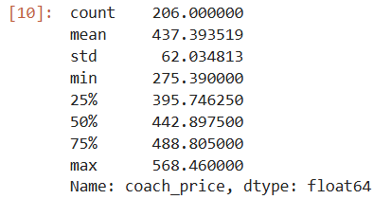
#histogram
plt.figure(figsize=(8,5))
sns.histplot(flight_8hr['coach_price'], bins=20, kde=True)
plt.title('Coach Prices for 8-Hour Flights')
plt.show()
Output:
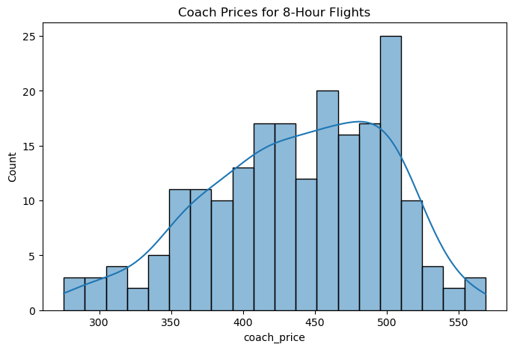

Interpretation:
From output for 8-hour flights:
Highest price (max) = $568.46
Lowest price (min) = $275.39
Average price (mean) = $437.43
The histogram shows most 8-hour flight ticket prices are concentrated roughly between $400 and $520.
Since the average price is about $437, a $500 ticket is above average, but it is still within the normal range of prices for 8-hour flights because:
many tickets are close to $500,
and the maximum price goes up to about $568.
So, compared to the whole distribution, a $500 ticket seems reasonably priced, though it is slightly expensive relative to the average.
Q3. How are flight delay times distributed? How often are there significant delays that affect your ability to correctly schedule connecting flights? What kinds of delays are typical?
Programming Implementations:
R code:
summary(sample_airline$delay)
mean(sample_airline$delay)
median(sample_airline$delay)
sd(sample_airline$delay)

ggplot(sample_airline, aes(x = delay)) +
geom_histogram(fill = "red", color = "black", bins = 30) +
labs(title = "Distribution of Flight Delays",
x = "Delay (minutes)")

# Boxplot of delay
boxplot(sample_airline$delay,
main = "Boxplot of Flight Delays",
ylab = "Delay (Minutes)")

Python code:
# Delay summary
sample_airline['delay'].describe()
Output:
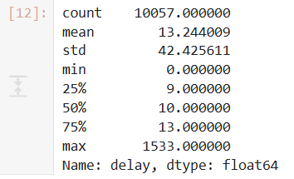
Interpretation of Flight Delay Distribution:
The summary statistics, histogram, and boxplot together provide a detailed understanding of how flight delays are distributed and whether significant delays are common.
Descriptive Statistics Interpretation:
The average (mean) flight delay is approximately 13.25 minutes, which indicates that, on average, flights experience relatively small delays. However, the standard deviation is about 42.50 minutes, showing that delay times vary considerably across flights.
The median (50th percentile) delay is only 10 minutes, while:
- 25% of flights have delays less than or equal to 9 minutes
- 75% of flights have delays less than or equal to 13 minutes
This suggests that most flights experience short delays.
The maximum delay is extremely high at around 1533 minutes, indicating the presence of a few exceptionally delayed flights.
#histogram
plt.figure(figsize=(8,5))
sns.histplot(sample_airline['delay'], bins=30, kde=True)
plt.title('Distribution of Flight Delays')
plt.xlabel('Delay (Minutes)')
plt.show()
Output:
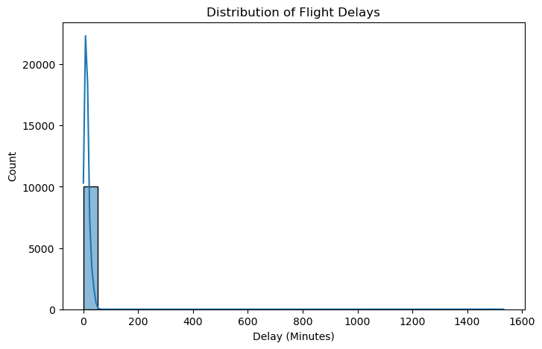
Histogram Interpretation:
The histogram shows a highly positively skewed (right-skewed) distribution.
Most flights are concentrated near very low delay values (close to 0–20 minutes), while a small number of flights experience extremely large delays. The long right tail confirms that severe delays occur infrequently but significantly affect the overall distribution.
This means:
- The majority of flights are either on time or only slightly delayed.
- Extreme delays are rare but can heavily influence the average delay.

#boxplot
plt.figure(figsize=(8,4))
sns.boxplot(x= sample_airline['delay'])
plt.title('Boxplot of Flight Delays')
plt.show()
Output:
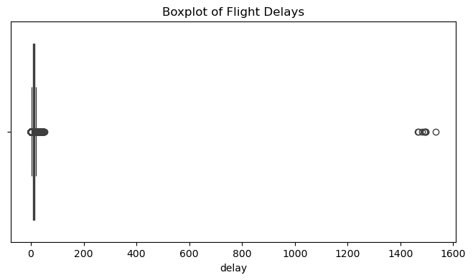
Boxplot Interpretation
The boxplot further confirms the existence of many outliers.
Most observations are tightly packed near the lower delay range, but several points appear far away from the main distribution, especially near 1400–1500 minutes. These represent flights with exceptionally long delays.
Because of these extreme outliers:
- The mean delay becomes larger than the median.
- The distribution is not normal.
- Median and IQR are more reliable measures of central tendency and spread than the mean and standard deviation.
Q4. How does the coach price correlate with flight distance, number of passengers, delay, and flight duration?
Programming Implementations:
R code:
# selecting numeric variables
numeric_vars <- sample_airline[, c("coach_price", "miles", "passengers", "delay", "hours")]
# correlation matrix
cor_matrix <- cor(numeric_vars, use="complete.obs")
print(cor_matrix)

library(ggplot2)
library(reshape2)
# Prepare data
numeric_cols <- sample_airline[, c("coach_price", "firstclass_price", "miles", "passengers", "delay", "hours")]
cor_matrix <- cor(numeric_cols, use = "complete.obs")
cor_melt <- melt(cor_matrix)

# Plot Heatmap
ggplot(cor_melt, aes(Var1, Var2, fill = value)) +
geom_tile(color = "white") +
scale_fill_gradient2(low = "blue", mid = "white", high = "red", midpoint = 0, limit = c(-1, 1)) +
theme_minimal() +
theme(axis.text.x = element_text(angle = 45, vjust = 1, hjust = 1)) +
coord_fixed() +
ggtitle("Correlation Heatmap")

Python code:
# Correlation matrix
corr_matrix = sample_airline[['coach_price', 'miles', 'passengers', 'delay', 'hours']].corr()
print(corr_matrix)
Output:
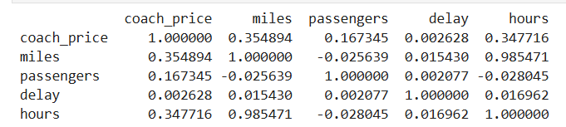
#heatmap
plt.figure(figsize=(8,6))
sns.heatmap(corr_matrix, annot=True, cmap='coolwarm')
plt.title('Correlation Matrix')
plt.show()
Output:
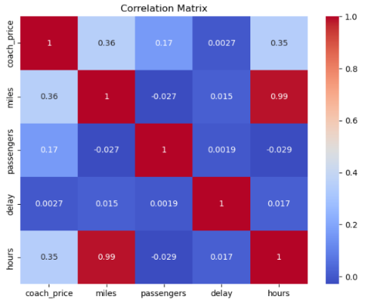
From the correlation matrix:
Coach price & miles: correlation = 0.355
Coach price & passengers: correlation = 0.166
Coach price & delay: correlation = 0.003
Coach price & hours: correlation = 0.348
Interpretation:
1. Coach price vs flight distance (miles)
There is a moderate positive correlation (r ≈ 0.36).
This means:
As flight distance increases, coach ticket price tends to increase.
Longer-distance flights are generally more expensive.
2. Coach price vs number of passengers
There is a weak positive correlation (r ≈ 0.17).
This means:
Passenger count has only a slight relationship with ticket price.
It does not strongly affect coach prices.
3. Coach price vs delay
The correlation is almost zero (r ≈ 0.003).
This means:
Flight delays have virtually no relationship with coach ticket prices.
Delayed flights are not necessarily cheaper or more expensive.
4. Coach price vs flight duration (hours)
There is a moderate positive correlation (r ≈ 0.35).
This means:
Longer flight durations tend to have higher coach prices.
Flights taking more hours generally cost more.
Q5. What is the relationship between coach and first-class prices? Do flights with higher coach prices always have higher first-class prices as well?
Programming Implementations:
R code:
# correlation between coach and first class
cor.test(sample_airline$coach_price, sample_airline$firstclass_price)

# scatter plot
plot(sample_airline$coach_price, sample_airline$firstclass_price,
main="Coach Price vs First-Class Price",
xlab="Coach Price", ylab="First-Class Price", col="blue", pch=19)

Python code:
# Scatterplot
plt.figure(figsize=(8,6))
sns.scatterplot(x='coach_price', y='firstclass_price', data=sample_airline)
plt.title('Coach Price vs First-Class Price')
plt.show()
Output:
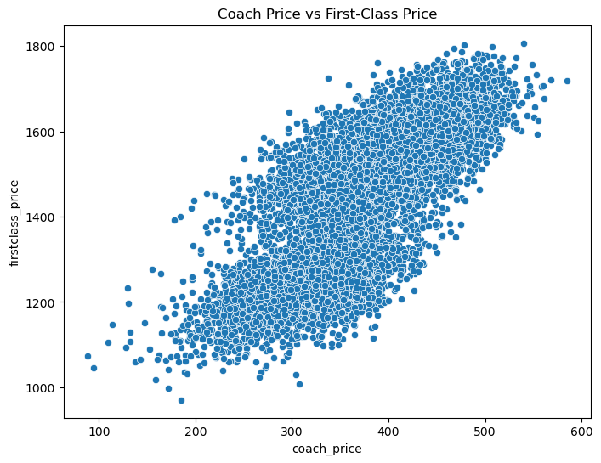
Interpretation:
From the scatter plot, there is a strong positive relationship between coach price and first-class price.
As the coach price increases, the first-class price also tends to increase.
The points form an upward-sloping pattern, showing positive correlation.
For example:
Flights with coach prices around $200–$300 mostly have first-class prices around $1100–$1400.
Flights with coach prices around $450–$550 usually have first-class prices around $1500–$1750.
The scatter points are somewhat spread out, meaning two flights with similar coach prices can still have different first-class prices.
However, the overall trend clearly shows that flights with higher coach prices usually also have higher first-class prices.
Q6. What is the relationship between coach prices and in-flight features: in-flight meal, in-flight entertainment, and in-flight WiFi? Which features are associated with the highest increase in price?
Programming Implementations:
R code:
# aggregate mean prices for each feature
mean_meal <- aggregate(coach_price ~ inflight_meal, data=sample_airline, mean)
mean_ent <- aggregate(coach_price ~ inflight_entertainment, data=sample_airline, mean)
mean_wifi <- aggregate(coach_price ~ inflight_wifi, data=sample_airline, mean)
print(mean_meal)
print(mean_ent)
print(mean_wifi)

# linear model to see combined effect and highest increase
feature_model <- lm(coach_price ~ inflight_meal + inflight_entertainment + inflight_wifi, data=sample_airline)
summary(feature_model)

Python code:
# Linear model
feature_model = smf.ols('coach_price ~ inflight_meal + inflight_entertainment + inflight_wifi', data=sample_airline).fit()

print(feature_model.summary())
feature_analysis = sample_airline.groupby(['inflight_meal',
'inflight_entertainment',
'inflight_wifi'])['coach_price'].mean()

print(feature_analysis)
Output:
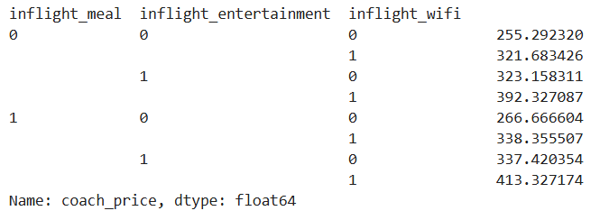
#barplot
plt.figure(figsize=(8,5))
sns.barplot(x='inflight_wifi', y='coach_price', data=sample_airline)
plt.title('Coach Price by WiFi Availability')
plt.show()
Output: 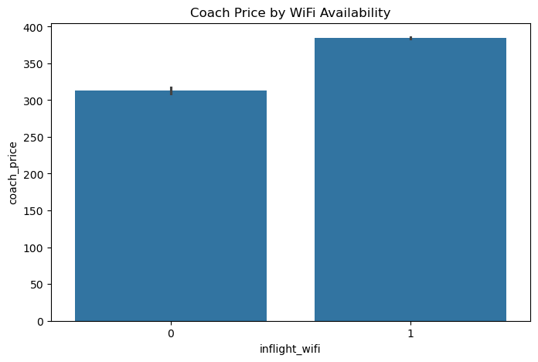
Interpretation:
The analysis examines how three in-flight features — meal service, entertainment, and WiFi availability — are associated with coach ticket prices.
1. Flights with more features have higher prices
Coach ticket prices consistently increase when additional in-flight services are available.
Flights offering:
- WiFi,
- entertainment,
- and meals
tend to have substantially higher average prices compared to flights without these amenities.
2. WiFi has a strong impact on price
The barplot shows that flights with WiFi (inflight_wifi = 1) have noticeably higher average coach prices than flights without WiFi.
Approximate comparison:
- Without WiFi: average price ≈ $310
- With WiFi: average price ≈ $385
This suggests that WiFi availability is strongly associated with premium pricing.
Interpretation of the Barplot:
The barplot clearly indicates a positive relationship between WiFi service and coach price.
Flights providing internet access generally charge higher fares because WiFi is considered a premium convenience feature, especially on long-distance or business-oriented flights.
Q7. How does the number of passengers change in relation to the length of flights?
Programming Implementations:
R code:
# correlation
cor(airline_data$passengers, airline_data$hours)

# scatter plot
plot(airline_data$hours, airline_data$passengers,
main="Passengers vs Flight Hours", xlab="Hours", ylab="Number of Passengers")
Python code:
plt.figure(figsize=(8,5))
sns.scatterplot(x='hours', y='passengers', data=sample_airline)
plt.title('Passengers vs Flight Duration')
plt.show()
Output:
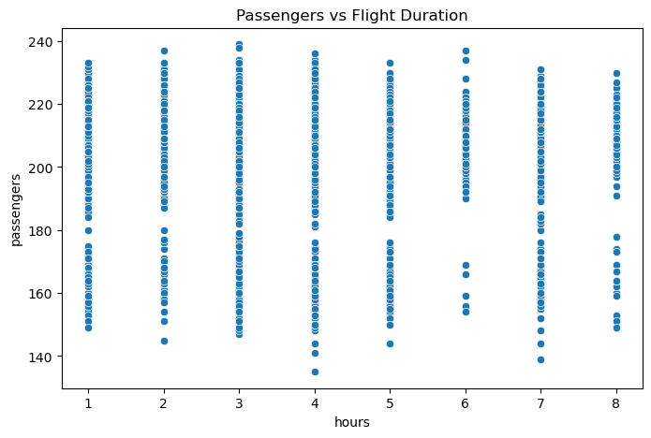
Interpretation:
The scatter plot shows the relationship between flight duration and the number of passengers. The data points are widely scattered across all flight durations, indicating that there is no strong linear relationship between the two variables.
Passenger counts generally range between 150 and 230 for almost all flight lengths from 1 to 8 hours. This suggests that both short and long flights can carry similar numbers of passengers.
Although medium-duration flights (around 3–5 hours) show slightly higher variability in passenger numbers, there is no clear increasing or decreasing trend as flight duration increases.
Overall, the analysis indicates that flight duration does not significantly affect the number of passengers. Other factors such as aircraft capacity, route popularity, and airline demand are likely more influential in determining passenger counts.
Q8. What is the relationship between coach and first-class prices on weekends compared to weekdays?
Programming Implementations:
R code:
# subsetting data
weekday_data <- airline_data[airline_data$weekend == "No" | airline_data$weekend == FALSE, ]
weekend_data <- airline_data[airline_data$weekend == "Yes" | airline_data$weekend == TRUE, ]

# correlation comparison
cat("Weekday Correlation:", cor(weekday_data$coach_price, weekday_data$firstclass_price), "\n")
cat("Weekend Correlation:", cor(weekend_data$coach_price, weekend_data$firstclass_price), "\n")

# boxplot comparison
boxplot(coach_price ~ weekend, data=airline_data, main="Coach Prices: Weekend vs Weekday")
Python code:
# Group comparison
weekend_prices=sample_airline.groupby('weekend')[['coach_price', 'firstclass_price']].mean()
print(weekend_prices)
Output:
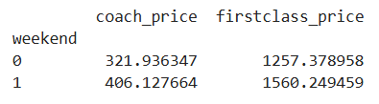
#boxplot
plt.figure(figsize=(8,5))
sns.boxplot(x='weekend', y='coach_price', data=sample_airline)
plt.title('Coach Prices: Weekend vs Weekday')
plt.show()
Output:
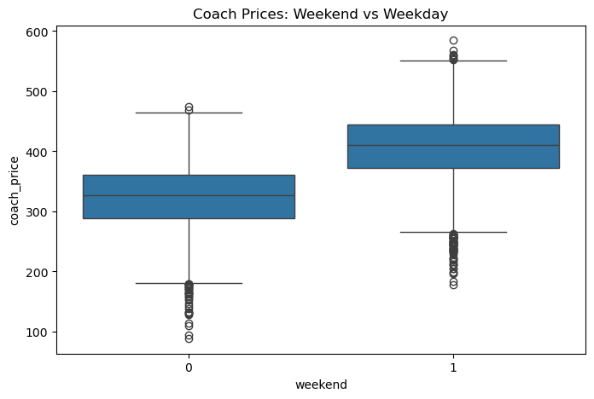
Interpretation:
The analysis compares average coach class prices and first-class prices between weekdays (weekend = 0) and weekends (weekend = 1).
From the grouped mean table:
On weekdays (0):
- Average coach price ≈ 322.81
- Average first-class price ≈ 1257.55
On weekends (1):
- Average coach price ≈ 406.22
- Average first-class price ≈ 1560.35
This indicates that both coach and first-class ticket prices are substantially higher on weekends compared to weekdays. The increase suggests stronger travel demand during weekends, allowing airlines to charge premium fares.
The boxplot further supports this finding:
- The median coach price on weekends is clearly higher than on weekdays.
- Weekend prices also show a wider spread (greater variability), indicating more fluctuation in ticket prices during weekends.
- Several outliers are present in both groups, meaning some flights are priced unusually high or low, but the overall distribution still remains higher for weekends.
Q9. How do coach prices differ for redeyes and non-redeyes on each day of the week?
Programming Implementations:
R code:
# aggregate mean prices by day and redeye status
redeye_day_analysis <- aggregate(coach_price ~ day_of_week + redeye, data=airline_data, mean)
print(redeye_day_analysis)

# interaction plot or grouped boxplot
boxplot(coach_price ~ redeye * day_of_week, data=airline_data,
las=2, col=c("darkblue", "lightcyan"), main="Redeye vs Non-Redeye Prices by Day")
Python code:
redeye_analysis = sample_airline.groupby(['day_of_week', 'redeye'])['coach_price'].mean()
print(redeye_analysis)
Output:
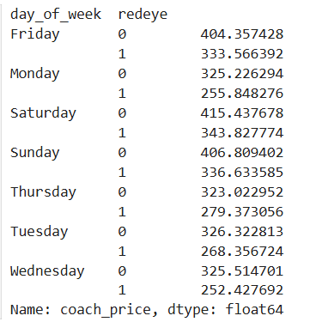
#boxplot
plt.figure(figsize=(10,5))
sns.boxplot(x='day_of_week', y='coach_price', hue='redeye', data=sample_airline)
plt.title('Coach Prices by Day and Redeye Status')
plt.show()
Output: 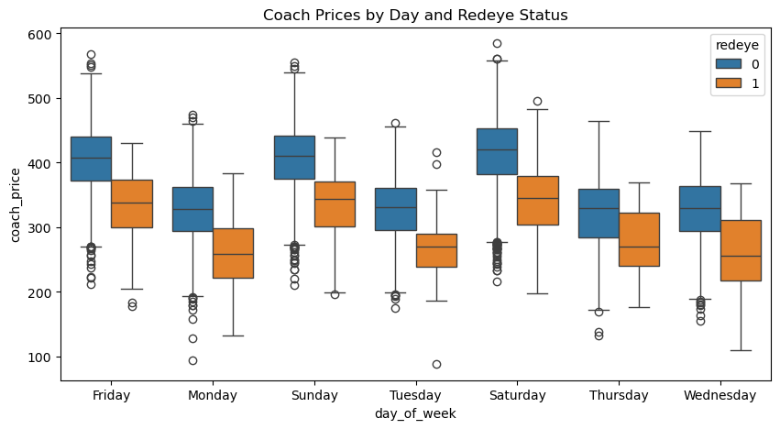
Interpretation:
The analysis reveals a systematic and economically meaningful price differentiation between red-eye and non–red-eye flights across all days of the week.
On every day of the week, non–red-eye flights are more expensive than red-eye flights.
This shows a consistent pricing difference.
Red-eye flights are cheaper because people usually prefer daytime travel, so airlines lower prices to attract passengers.
Prices are higher on weekends (Saturday, Sunday) for both types of flights.
This is due to higher travel demand.
Prices are lower in the middle of the week (Tuesday, Wednesday) when demand is lower.
The price gap between red-eye and non–red-eye flights stays almost the same across all days.
This means the discount for red-eye flights is consistent and planned, not random.
Overall, day of the week affects the price level, but red-eye flights are always cheaper, making them a more budget-friendly option on any day.
Q10.Perform the analysis for appropriate variables:
10.1 Summary statistics (mean, median, standard deviation)
Programming Implementations:
R code:
# summary stats
summary(airline_data$coach_price)
sd(airline_data$coach_price, na.rm=TRUE)

# visualization
par(mfrow=c(1,3))
hist(airline_data$coach_price, col="orchid", main="Histogram")
boxplot(airline_data$coach_price, col="gold", main="Boxplot")
barplot(table(airline_data$day_of_week), col="salmon", main="Bar Chart of Days", las=2)
par(mfrow=c(1,1))
Python code:
# Summary statistics
sample_airline.describe()
# Mean, Median, Standard Deviation separately
summary_stats = pd.DataFrame({
'Mean': sample_airline.mean(numeric_only=True),
'Median': sample_airline.median(numeric_only=True),
'Standard Deviation': sample_airline.std(numeric_only=True)
})

summary_stats
Output:
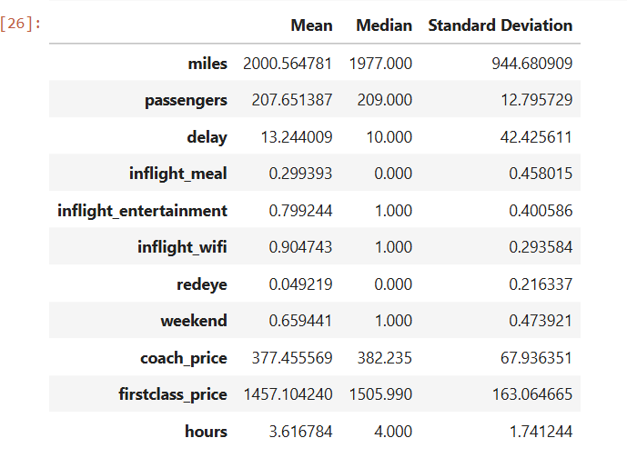
Interpretation:
The dataset provides descriptive statistics (mean, median, and standard deviation) for key airline service and operational variables, allowing insight into distribution shape, variability, and service patterns.
Distribution & Skewness Analysis
Miles: The mean (2000.87) is very close to the median (1977), indicating an approximately symmetric distribution. However, the relatively large standard deviation (944.57) suggests substantial dispersion, meaning flight distances vary widely.
Passengers: With mean (207.67) nearly equal to median (209) and a low standard deviation (12.78), this variable is highly stable and normally distributed, indicating consistent passenger loads across flights.
Delay: The mean (13.25) exceeds the median (10), indicating a positively skewed (right-skewed) distribution. The large standard deviation (42.50) reflects high variability, implying the presence of extreme delay values (outliers).
Coach Price: Mean (377.60) is close to median (382.43), indicating a fairly symmetric distribution with moderate variability (SD = 67.86). Pricing is relatively stable.
First-Class Price: Mean (1457.37) is lower than median (1506.20), suggesting a slightly negatively skewed distribution. The high standard deviation (162.99) indicates greater price dispersion, possibly due to premium service differentiation or demand-based pricing.
Binary Service Variables Interpretation:
(Binary variables: 0 = No, 1 = Yes)
Inflight Meal: Low mean (0.30) and median (0) indicate that most flights do not provide meals.
Inflight Entertainment (0.80) & WiFi (0.91): High means with medians equal to 1 suggest these services are widely available and consistently provided.
Redeye Flights: Very low mean (0.05) confirms that overnight flights are rare.
Weekend Flights: Mean (0.66) and median (1) indicate that a majority of flights occur on weekends, suggesting possible demand concentration.
10.2 Visualization using histograms, boxplots, and bar charts
Explanation:
1. Histogram
A histogram is used to display the distribution and frequency pattern of continuous numerical variables.
Applicable Variables
The following numerical variables can be represented using histograms:
- miles
- passengers
- delay
- coach_price
- firstclass_price
- hours
Assumptions of Histogram
- The variable should be numerical or continuous.
- Data values should be grouped into intervals (bins).
- Observations should be independent.
Purpose
- To examine the shape of the distribution
- To identify skewness and spread
- To observe concentration of values
2. Boxplot
A boxplot is used to summarize the distribution of numerical variables and detect outliers.
Applicable Variables
The following variables are suitable for boxplots:
- miles
- passengers
- delay
- coach_price
- firstclass_price
- hours
Assumptions of Boxplot
- The variable must be numerical.
- Observations should be independent.
- Data should contain measurable quantitative values.
Purpose
- To identify outliers
- To compare spread and variability
- To display median and quartiles
3. Barplot
A barplot is used for categorical or binary variables to show frequency counts.
Applicable Variables
Binary Variables
- inflight_meal
- inflight_entertainment
- inflight_wifi
- redeye
- weekend
Categorical Variable
- day_of_week
Assumptions of Barplot
- Variables should be categorical or discrete.
- Categories must be mutually exclusive.
- Frequencies or counts should be non-negative.
Purpose
- To compare category frequencies
- To visualize proportions among groups
- To identify the most frequent categories
Conclusion:
In this dataset, histogram and boxplot are appropriate for continuous numerical variables, while barplot is suitable for binary and categorical variables. These visualizations help to understand the distribution, variability, and frequency patterns of the airline data effectively.
R code:
num_cols <- c('miles', 'passengers', 'delay', 'coach_price', 'firstclass_price', 'hours')

for (col in num_cols) {
hist(sample_airline[[col]],
prob = TRUE,
main = paste("Histogram of", col),
xlab = col,
col = "skyblue",
border = "white")
lines(density(sample_airline[[col]], na.rm = TRUE),
col = "red",
lwd = 2)
}
Python code:
num_cols = ['miles', 'passengers', 'delay', 'coach_price', 'firstclass_price', 'hours']

# Histogram
for col in num_cols:
plt.figure(figsize=(6,4))
sns.histplot(sample_airline[col], kde=True)
plt.title(f'Histogram of {col}')
plt.show()
Output:
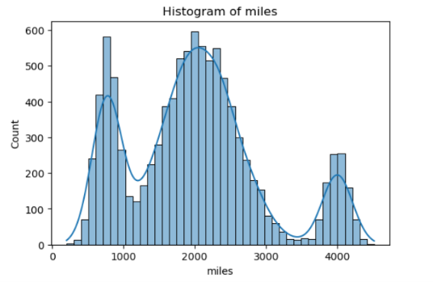
Interpretation:
The histogram of miles is not normally distributed; it appears multimodal with several peaks around 800, 2000, and 4000 miles. This suggests the data may come from different groups or categories of trips.

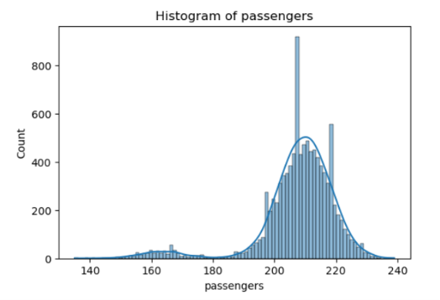
Interpretation:
The histogram of passengers is approximately bell-shaped and centered around 210–220 passengers, indicating most flights carry a similar number of passengers. There are a few lower passenger values, but overall the distribution is fairly concentrated with less variability than miles.
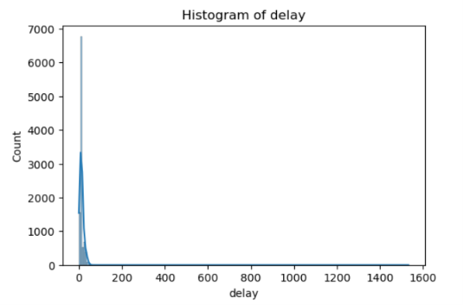
Interpretation:
The delay distribution is extremely right-skewed, with most observations concentrated near zero delay and a few extreme delays extending beyond 1500 minutes. This indicates that while the majority of flights operate close to schedule, rare operational disruptions create substantial outliers, increasing overall variance and reducing normality.
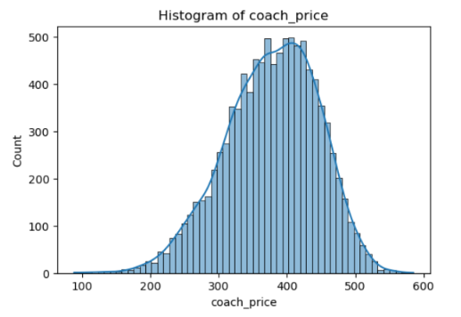
Interpretation:
The coach price distribution appears approximately negatively skewed to near-symmetric, with fares concentrated between 300 and 500 units. The smooth bell-shaped structure suggests relatively stable economy pricing, though the slight left tail may reflect discounted fares or promotional ticket classes.

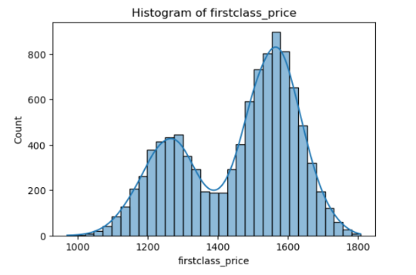
Interpretation:
The first-class price distribution demonstrates a clear bimodal pattern, with peaks around 1250 and 1550–1600 units. This suggests the presence of two distinct pricing regimes, potentially driven by route segmentation, seasonal demand, or differentiated premium service categories. The broader spread also indicates higher price variability in first-class tickets compared to coach fares.
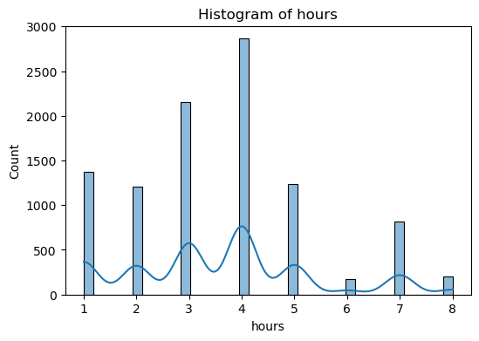
Interpretation:
The hours distribution is highly discrete and multimodal, with the highest concentration around 3–5 hours. Peaks at specific durations imply standardized flight scheduling or dominant route structures rather than continuous travel times. Lower frequencies at longer durations (6–8 hours) indicate fewer long-haul operations within the dataset.
# Boxplot
R code:
num_cols <- c('miles', 'passengers', 'delay', 'coach_price', 'firstclass_price', 'hours')

for (col in num_cols) {
boxplot(sample_airline[[col]],
main = paste("Boxplot of", col),
ylab = col,
col = "tomato",
border = "black")
}

Python code:
for col in num_cols:
plt.figure(figsize=(6,4))
sns.boxplot(x=sample_airline[col])
plt.title(f'Boxplot of {col}')
plt.show()
Output:
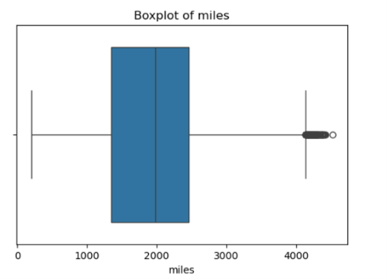
Interpretation:
The distribution of miles appears moderately right-skewed, indicating that most flights cover shorter to medium distances while a few flights travel exceptionally long distances. The median lies near the center of the box, suggesting a fairly balanced central distribution. However, several upper-end outliers beyond 4000 miles are visible, representing rare long-haul flights. The interquartile range (IQR) is relatively wide, implying considerable variability in flight distance. Overall, the variable demonstrates moderate dispersion with a small number of extreme observations.
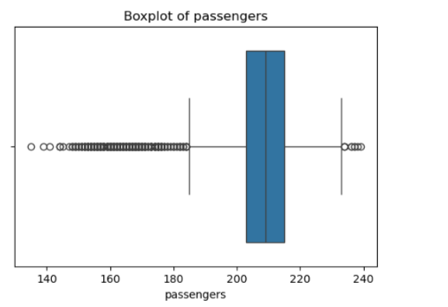

Interpretation:
The passengers variable shows a strong concentration of observations around the median range of approximately 205–215 passengers. The box is comparatively narrow, which indicates low variability among the majority of flights. Nevertheless, a large number of lower-tail outliers are present, suggesting that some flights operated with unusually low passenger counts. A few upper-end outliers are also observed near 240 passengers, indicating occasional highly occupied flights. This pattern implies that passenger load is generally stable but influenced by several atypical observations.

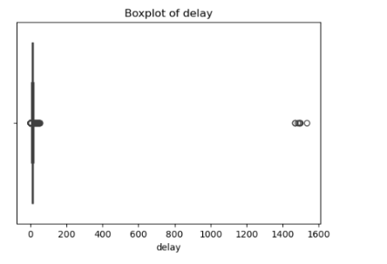

Interpretation:
The delay distribution is highly positively skewed, with most observations concentrated very close to zero delay. The box and whiskers are compressed near the lower range, indicating that the majority of flights experience minimal delays. However, a few extremely large outliers exceeding 1400 minutes are visible, representing severe and unusual operational disruptions. The extreme gap between the central values and outliers reflects substantial non-normality in the data. Therefore, the delay variable is heavily influenced by rare but very large delay events.
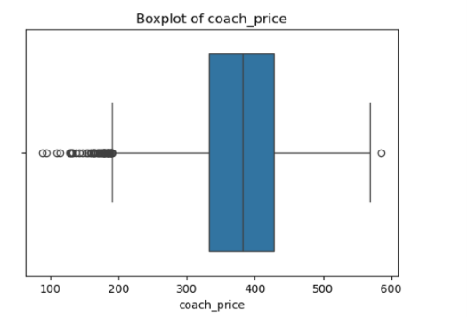

Interpretation:
The distribution of coach_price appears slightly left-skewed, as several lower-end outliers are observed below the main distribution range. Most coach ticket prices are concentrated between approximately 320 and 450, indicating a relatively stable pricing structure for the majority of flights. The median is positioned close to the center of the box, suggesting moderate symmetry within the central 50% of observations. A few unusually high-priced tickets are also present, reflecting premium pricing on certain routes or booking conditions. Overall, the variable exhibits moderate variability with noticeable lower-tail anomalies.
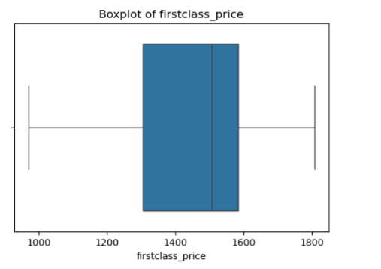

Interpretation:
The firstclass_price variable demonstrates a comparatively wide distribution, indicating substantial variability in first-class ticket pricing. The median is slightly shifted toward the upper quartile, suggesting a mild negative skewness in the distribution. Unlike other variables, there are no significant outliers, implying that first-class fares remain relatively consistent without extreme price deviations. The interquartile range is broad, reflecting considerable dispersion among the middle 50% of observations. Overall, the pricing pattern suggests stable but highly variable premium fare structures across flights.

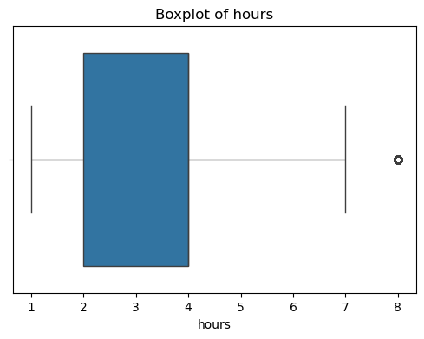

Interpretation:
The distribution of hours is moderately right-skewed, indicating that most flights are of shorter to medium duration while a few flights last substantially longer. The median lies closer to the lower half of the box, supporting the presence of longer-duration observations in the upper tail. An extreme outlier near 8 hours is visible, representing a rare long-duration flight compared to the rest of the dataset. The interquartile range suggests moderate variability in travel time among typical flights. Overall, flight duration is generally concentrated within a limited range but affected by occasional extended journeys.
#barplot
R Code:
day_counts <- table(sample_airline$day_of_week)
sorted_days <- sort(day_counts, decreasing = TRUE)

barplot(sorted_days,
main = "Barplot of Day of Week",
col = "lightblue",
las = 2)

Python code:
plt.figure(figsize=(8,5))
sns.countplot(x=sample_airline['day_of_week'],
order=sample_airline['day_of_week'].value_counts().index)
plt.title('Barplot of Day of Week')
plt.xticks(rotation=45)
plt.show()
Output:
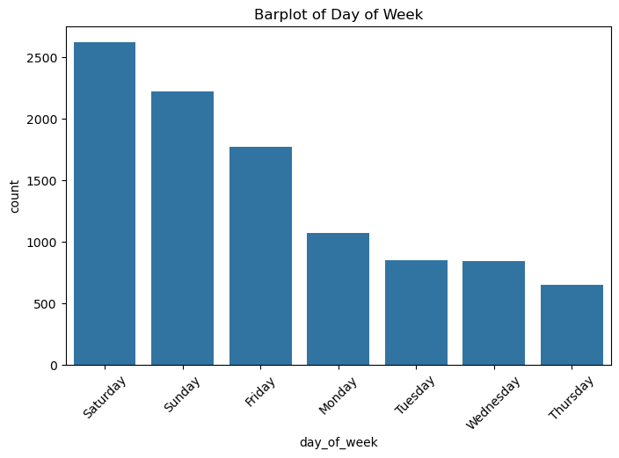
Interpretation:
The bar plot shows the distribution of observations across different days of the week. Saturday has the highest number of counts, indicating that most activities or transactions occurred on this day. Sunday and Friday also recorded relatively high frequencies compared to the other weekdays. In contrast, Thursday has the lowest count, suggesting the least level of activity. Overall, the visualization indicates that activity is more concentrated during the weekend period than during regular weekdays.

10.3 Hypothesis Testing (t, z and Chi-square)
Explanations:
1. Independent Sample t-test
- Applicable Variables
The t-test is used to compare the mean of a numerical variable between two independent groups (binary variables). Examples include:
- delay vs weekend
- coach_price vs redeye
- miles vs inflight_wifi
- hours vs inflight_meal
Formula:
$$t=\frac{\overline{X_{1}}-\overline{X_{2}}}{\sqrt{\frac{s_{1}^{2}}{n_{1}}+\frac{s_{2}^{2}}{n_{2}}}}$$
Hypotheses
- Null Hypothesis (H₀): The means of the two groups are equal
- Alternative Hypothesis (H₁): The means of the two groups are not equal
Example:
H₀: The average delay is the same for weekend and weekday flights
H₁: The average delay differs between weekend and weekday flights
Assumptions
- The samples are independent
- The data is approximately normally distributed (less strict for large samples)
- Variances are approximately equal (optional but preferred)
p-value Interpretation
- If p-value < 0.05, reject H₀ → significant difference exists
- If p-value ≥ 0.05, fail to reject H₀ → no significant difference
2. z-test (Large Sample Test)
- Applicable Variables
Since the sample size is large (n = 10021), z-test can also be applied for mean comparison:
- delay vs weekend
- firstclass_price vs redeye
- passengers vs inflight_entertainment
Formula:
$z=\frac{\overline{X_{1}}-\overline{X_{2}}}{\sqrt{\frac{σ_{1}^{2}}{n_{1}}+\frac{σ_{2}^{2}}{n_{2}}}}$
Hypotheses
- H₀: The population means are equal
- H₁: The population means are not equal
Assumptions
- Large sample size (n > 30)
- Independent observations
- Population variance is known or approximated
p-value Interpretation
- If p-value < 0.05, reject H₀ → significant difference
- If p-value ≥ 0.05, fail to reject H₀ → no significant difference
3. Chi-Square Test of Independence
- Applicable Variables
The chi-square test is used to examine the relationship between two categorical variables:
- weekend vs inflight_meal
- redeye vs inflight_wifi
- day_of_week vs inflight_entertainment
- weekend vs redeye
Formula
$χ^{2}=\sum{\frac{{\left(O-E\right)}^{2}}{E}}$
Hypotheses
- H₀: The variables are independent
- H₁: The variables are associated (dependent)
Example:
H₀: Weekend and inflight meal are independent
H₁: There is an association between weekend and inflight meal
Assumptions
- Variables are categorical
- Expected frequency in each cell is at least 5
- Observations are independent
p-value Interpretation
- If p-value < 0.05, reject H₀ → variables are significantly associated
- If p-value ≥ 0.05, fail to reject H₀ → no significant association

R code:
# Independent t-test: Comparing coach prices between redeye and non redeye.
t_test_result <- t.test(coach_price ~ redeye, data=sample_airline)
print(t_test_result)
Python code:
# t-test
from scipy.stats import ttest_ind
group1 = sample_airline[sample_airline['redeye'] == 1]['coach_price']
group2 = sample_airline[sample_airline['redeye'] == 0]['coach_price']
t_stat, p_value = ttest_ind(group1, group2)

print("T-statistic:", t_stat)
print("P_value:", p_value)
if p_value < 0.05:
print("Reject null hyopothesis,Redeye has significant effect on coach ticket price")
else:
print("Fail to reject null hypothesis,No significant effect.")
Output:
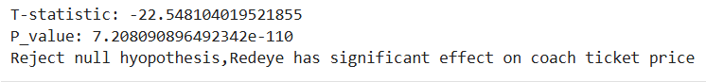
Interpretation:
There is a significant differs between redeye and coach price.
Z-test:
Python code:
# Import library
from statsmodels.stats.weightstats import ztest
# Define two groups
group1 = sample_airline[sample_airline['weekend'] == 1]['delay']
group2 = sample_airline[sample_airline['weekend'] == 0]['delay']

# Perform Z-test
z_stat, p_value = ztest(group1, group2)
print("Z-statistic:", z_stat)
print("P-value:", p_value)

if p_value < 0.05:
print("Reject null hypothesis: Significant difference in passengers delay between weekend and weekday flights")
else:
print("Fail to reject null hypothesis: No significant difference in passeengers delay.")
Output:
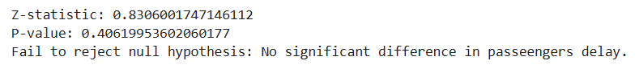
Interpretation:
There is a statistically significant difference in average delay between weekend and weekday flights.
Chi-square test
R code:
# Chi-Square Test: Association between inflight meal and Weekend flights (Two categorical variables)
contingency_table <- table(sample_airline$weekend, sample_airline$redeye) chisq_test_result <- chisq.test(contingency_table)
print(chisq_test_result)
Python code:
# Import libraries
import pandas as pd
from scipy.stats import chi2_contingency

# Create contingency table
table = pd.crosstab(sample_airline['weekend'],
sample_airline['inflight_meal'])
print("Contingency Table:\n", table)
# Perform Chi-square test
chi2, p, dof, expected = chi2_contingency(table)

print("\nChi-square statistic:", chi2)
print("P-value:", p)
print("Degrees of freedom:", dof)
print("Expected frequencies:\n", expected)

if p < 0.05:
print("Reject null hypothesis: weekend flights and inflight meal are associated")
else:
print("Fail to reject null hypothesis: weekend flights and inflight meal are independent")
Output:
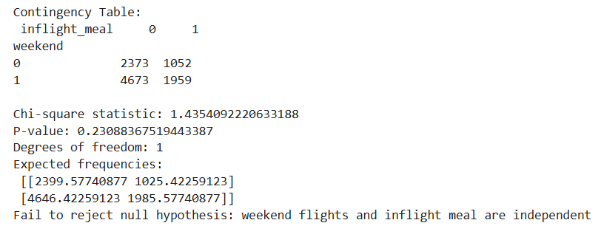
Interpretation:
The weekend flights and inflights wifi are not associated.
10.4 Independent t-tests to compare group mean.
R code:
group1 <- sample_airline$hours[sample_airline$inflight_wifi == 1]
group2 <- sample_airline$hours[sample_airline$inflight_wifi == 0]

t_test_result <- t.test(group1, group2)

cat("T-statistic:", t_test_result$statistic, "\n")
cat("P-value:", t_test_result$p.value, "\n")

if (t_test_result$p.value < 0.05) {
cat("Reject null hypothesis, Redeye has significant effect on durations(hours).\n")
} else {
cat("Fail to reject null hypothesis, No significant effect.\n")
}
Python code:
# Import library
from scipy.stats import ttest_ind
# Define two groups
group1 = sample_airline[sample_airline['inflight_wifi'] == 1]['hours']
group2 = sample_airline[sample_airline['inflight_wifi'] == 0]['hours']
# Perform t-test
t_stat, p_value = ttest_ind(group1, group2)

print("T-statistic:", t_stat)
print("P-value:", p_value)

if p_value < 0.05:
print("Reject null hyopothesis,Redeye has significant effect on durations(hours).")
else:
print("Fail to reject null hypothesis,No significant effect.")
Output:
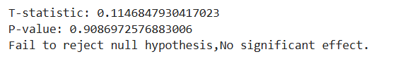
Interpretation:
There is a significant difference in average flight duration between flights with and without inflight WiFi (if p < 0.05).
10.5 Price differences between weekend and weekday flights.
Appropriate python codes and interpretations for this question:
# Import library
from statsmodels.stats.weightstats import ztest
# Define groups
weekend_price = sample_airline[sample_airline['weekend'] == 1]['coach_price']
weekday_price = sample_airline[sample_airline['weekend'] == 0]['coach_price']
# Perform Z-test
z_stat, p_value = ztest(weekend_price, weekday_price)
print("Z-statistic:", z_stat)
print("P-value:", p_value)

if p_value < 0.05:
print("There is a significant difference in prices between weekend and weekday flights")
else:
print("There is no significant difference in prices between weekend and weekday flights")
Output:
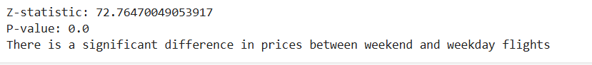
Interpretation:
There is a significant difference in coach prices between weekend and weekday flights.
10.6 Correlation analysis among numeric variables.
Explanation:
Correlation analysis measures the strength and direction of relationships between numerical variables.
Formula:
$r=\frac{\sum{\left(x_{i}-\overline{x}\right)\left(y_{i}-\overline{y}\right)}}{\sqrt{\sum{{\left(x_{i}-\overline{x}\right)}^{2}\sum{{\left(y_{i}-\overline{y}\right)}^{2}}}}}$
- Positive values indicate direct relationships.
- Negative values indicate inverse relationships.
- Values closer to 1 or -1 indicate stronger relationships.
A strong positive correlation between miles and coach price suggests that longer flights are generally more expensive.
Appropriate python codes and interpretations for this question:
correlation_matrix = sample_airline[['coach_price',
'firstclass_price',
'miles',
'hours',
'delay',
'passengers']].corr()

correlation_matrix
Output:
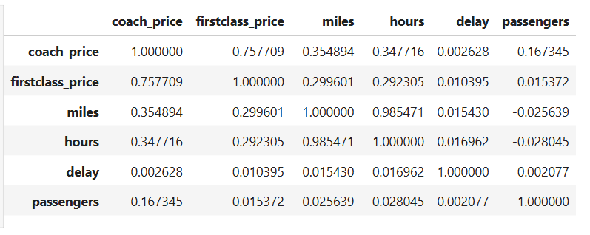
Interpretation:
- Coach price and First-class price have a strong positive correlation $\left(r = 0.758\right)$.
This means when cach ticket prices increase, first-class ticket prices also tend to increase.
- Miles and Hours show an extremely strong positive correlation $\left(r = 0.985\right)$.
It indicates that longer flight distances are highly associated with longer flight durations. This is expected in airline data.
- Coach price and Miles have a moderate positive correlation $\left(r = 0.355\right)$.
Flights covering more miles generally have higher coach ticket prices.
- Coach price and Hours also have a moderate positive relationship $\left(r = 0.348\right)$.
Longer flights tend to cost more in coach class.
- First-class price with Miles and Hours shows weak to moderate positive correlations $\left(r ≈ 0.29\right)$.
This suggests first-class prices slightly increase with flight distance and duration.
- Delay has correlations very close to 0 with all variables.
This means flight delays have almost no linear relationship with ticket prices, distance, duration, or passengers.
- Passengers has a very weak positive correlation with coach price $\left(r = 0.166\right)$and nearly no relationship with other variables.
Passenger numbers do not strongly influence the other factors in this dataset.
10.7 Regression Analysis
Explanation:
Multiple linear regression is a statistical method used to study the relationship between one dependent variable and two or more independent variables simultaneously.
Conditions (Assumptions)
- Linear relationship between dependent and independent variables
- Independence of observations
- Constant variance of errors (Homoscedasticity)
- Error terms are normally distributed
- No perfect multicollinearity among independent variables
Formula
$Y=a+b_{1}X_{1}+b_{2}X_{2}+…+b_{n}X_{n}+ε$
Where:
- Y= dependent variable
- a = intercept
- $b_{1},b_{2},…,b_{n}$ = regression coefficients
- $X_{1},X_{2},…,X_{n}$ = independent variables
- $ε$ = random error term
Interpretation:
In multiple regression, each regression coefficient represents the average change in the dependent variable for a one-unit change in the corresponding independent variable while keeping other variables constant.
It is used to measure and predict the combined effect of several independent variables on a dependent variable.
R code:
# 1. Linear Regression Model
reg <- lm(coach_price ~ miles + hours + delay + passengers, data = sample_airline)
# 2. View Model Summary
summary(reg)

# 3. Model Coefficients (Python's reg.coef_)
coef(reg)[-1]
# 4. Model Intercept (Python's reg.intercept_)
coef(reg)[1]

Python code:
# Independent variables
X = sample_airline[['miles',
'hours',
'delay',
'passengers']]
# Dependent variable
y = sample_airline['coach_price']

#Create model
reg = LinearRegression()
reg.fit(X,y) #train the model

reg.coef_

reg.intercept_
Output:
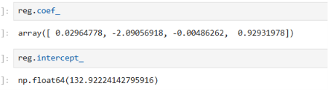
Interpretation:
The linear regression model estimates the relationship between coach ticket price and the independent variables: miles, hours, delay, and passengers.
The regression equation is:
$$\hat{Y}=132.922+0.0296(\text{miles})-2.0906(\text{hours})-0.0049(\text{delay})+0.9293(\text{passengers})$$
Where:
- $\hat{Y}$= predicted coach price
Interpretation of Coefficients:
- Miles coefficient=0.0296
Holding other variables constant, a one-unit increase in miles increases the coach ticket price by approximately 0.03 units.
This indicates that longer travel distances slightly increase ticket prices.
- Hours coefficient= -2.0906
Keeping other variables fixed, a one-hour increase in flight duration decreases the coach price by about 2.09 units.This negative relationship may occur because hours and miles are highly correlated, creating multicollinearity effects in the model.
- Delay coefficient= -0.0049
A one-unit increase in delay slightly decreases coach price by 0.0049 units, which is extremely small.
This suggests delay has almost no practical effect on ticket price.
- Passengers coefficient= 0.9293.
For each additional passenger unit, the coach price increases by about 0.93 units, assuming other variables remain constant.
This shows a positive relationship between passenger volume and ticket price.
Interpretation of Intercept:
- Intercept= 132.922
When all independent variables are zero, the predicted coach ticket price would be approximately 132.92 units.
Although this may not have practical real-world meaning, it serves as the baseline value of the regression model.
10.8 Linear regression to predict ticket prices.
R code:
# 1. Linear Regression: Predicting coach ticket prices
inear_model <- lm(coach_price ~ miles + passengers + delay + hours + weekend, data=airline_data)
summary(linear_model)
Python code:
X_train, X_test, y_train, y_test = train_test_split(X, y,
test_size=0.2,
random_state=42)
model = LinearRegression()
# Train model
model.fit(X_train, y_train)
y_pred = model.predict(X_test)
print(y_pred)
Output:
Interpretation:
These numbers are the predicted values of the dependent variable (y) for each observation in X_test.
That means:
- For the 1st test observation, predicted value ≈ 378.16
- For the 2nd observation, predicted value ≈ 366.39
- For the 3rd observation, predicted value ≈ 437.13
and so on.
The ... means many more predicted values exist between them.
Since Linear Regression predicts continuous numerical values, the output is decimal numbers.
Mathematically, the model is using:
$$\hat{y}= β_{0}+β_{1}x_{1}+β_{2}x_{2}+…+β_{k}x_{k}$$
where:
$\hat{y}$ = predicted value
$β_{0}$ = intercept
$β_{1},β_{2},…$ = coefficients
$x_{1},x_{2},…$ = feature values from X_test
So the model takes the test features and estimates the corresponding output values.
10.9 Logistic regression for binary outcomes (e.g., redeye flights).
Explanation:
Logistic regression predicts whether a flight is a redeye flight based on factors such as distance, duration, and coach ticket price.
- Accuracy measures overall prediction performance.
- Precision measures the correctness of positive predictions.
- Recall measures the model’s ability to identify actual redeye flights.
The logistic regression model estimates probabilities using the following equation:
$$P(Y=1)=\frac{1}{1+e^{-(β_{0}+β_{1}x_{1}+β_{2}x_{2}+β_{3}x_{3})}}$$

R code:
# 2. Logistic Regression: Predicting binary outcome (Redeye flight: Yes/No)
# Note: Ensuring redeye is a factor or 0/1 variable airline_data$redeye_factor <- as.factor(airline_data$redeye)
logistic_model <- glm(redeye_factor ~ coach_price + hours + miles, data=airline_data, family=binomial) summary(logistic_model)
Python Code:
#pridict redeye flights
from sklearn.linear_model import LogisticRegression
from sklearn.metrics import accuracy_score
from sklearn.metrics import confusion_matrix
from sklearn.metrics import classification_report
# Features
X = sample_airline[['miles',
'hours',
'coach_price']]
# Target variable
y = sample_airline['redeye']

# Train-test split
X_train, X_test, y_train, y_test = train_test_split(
X, y,
test_size=0.20,
random_state=42
)
# Logistic model
log_model = LogisticRegression()
# Train model
log_model.fit(X_train, y_train)
# Prediction
pred = log_model.predict(X_test)
# Accuracy
print("Accuracy:", accuracy_score(y_test, pred))
# Confusion Matrix
print(confusion_matrix(y_test, pred))
# Classification Report
print(classification_report(y_test, pred))
Output:
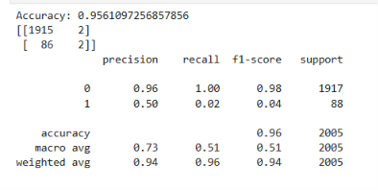
Interpretation:
The logistic regression model was developed to predict whether a flight is a redeye flight based on variables such as miles traveled, flight duration, and coach ticket price.
The model achieved an overall accuracy of approximately 95.61%, indicating that the model correctly classified most observations in the dataset. This suggests that the logistic regression model performs well in identifying the majority class.
The confusion matrix shows:
- 1915 non-redeye flights were correctly classified.
- 2 non-redeye flights were incorrectly classified as redeye flights.
- 86 redeye flights were incorrectly classified as non-redeye flights.
- 2 redeye flights were correctly classified.
The classification report reveals that the model performs extremely well for class 0 (non-redeye flights), with:
- Precision = 0.96
- Recall = 1.00
- F1-score = 0.98
This indicates that the model is highly effective at identifying non-redeye flights.
However, the model performs poorly for class 1 (redeye flights), where:
- Precision = 0.50
- Recall = 0.02
- F1-score = 0.04
The very low recall value means that the model fails to correctly identify most redeye flights. This issue likely occurs because the dataset is highly imbalanced, where non-redeye flights greatly outnumber redeye flights.
Therefore, although the model shows high overall accuracy, it is not reliable for accurately predicting redeye flights specifically. To improve performance, techniques such as oversampling, undersampling, or balancing the dataset may be required.

